6.EE.5 Understand solving an equation or inequality as a process of answering a question: which values from a specified set, if any, make the equation or inequality true? Use substitution to determine whether a given number in a specified set makes an equation or inequality true.

Example 1:
Joey had 26 papers in his desk. His teacher gave him some more and now he has 100. How many papers did his teacher give him?
This situation can be represented by the equation 26 + n = 100 where n is the number of papers the teacher gives to Joey.
Students could use several different strategies to find a solution to the problem:
- Reasoning: 26 + 70 is 96 and 96 + 4 is 100, so the number added to 26 to get 100 is 74.
- Use knowledge of fact families to write related equations:
n + 26 = 100, 100 - n = 26, 100 - 26 = n. Select the equation that helps to find n easily.
- Use knowledge of inverse operations: Since subtraction “undoes” addition then subtract 26 from 100 to get the numerical value of n
- Scale model: There are 26 blocks on the left side of the scale and 100 blocks on the right side of the scale. All the blocks are the same size. 74 blocks need to be added to the left side of the scale to make the scale balance.
- Bar Model: Each bar represents one of the values. Students use this visual representation to demonstrate that 26 and the unknown value together make 100.
100
26 n

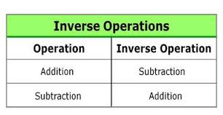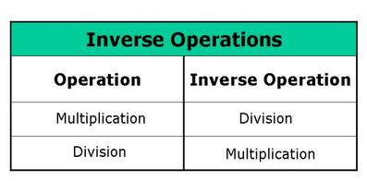

Student Notes:

Example 2:
Twelve is less than 3 times another number can be shown by the inequality 12 < 3n. What numbers could possibly make this a true statement?
Solution:
Since 3 • 4 is equal to 12 I know the value must be greater than 4. Any value greater than 4 will make the inequality true. Possibilities are 4.13, 6, 5 ¾ and 200. Given a set of values, students identify the values that make the inequality true.
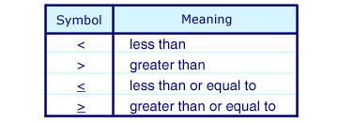
6.EE.6 Use variables to represent numbers and write expressions when solving a real-world or mathematical problem; understand that a variable can represent an unknown number, or, depending on the purpose at hand, any number in a specified set.

Students write expressions to represent various real-world situations.
Example Set 1:
- Write an expression to represent Susan’s age in three years, when a represents her present age.
- Write an expression to represent the number of wheels, w, on any number of bicycles.
- Write an expression to represent the value of any number of quarters, q.
Solutions:
- a + 3
- 2n
- 0.25q

Student Notes:

Example 2:
The skating rink charges $100 to reserve the place and then $5 per person. Write an expression to represent the cost for any number of people.
Possible Solutions:
- n = the number of people
- 100 + 5n

Example Set 3:
a. Maria has three more than twice as many crayons as Elizabeth. Write an algebraic expression to represent the number of crayons that Maria has.
Solution: 2c + 3 where c represents the number of crayons that Elizabeth has

b. An amusement park charges $28 to enter and $0.35 per ticket. Write an algebraic expression to represent the total amount spent.
Solution: 28 + 0.35t where t represents the number of tickets purchased

c. Andrew has a summer job doing yard work. He is paid $15 per hour and a $20 bonus when he completes the yard. He was paid $85 for completing one yard. Write an equation to represent the amount of money he earned.
Solution: 15h + 20 = 85 where h is the number of hours worked

d. Describe a problem situation that can be solved using the equation 2c + 3 = 15; where c represents the cost of an item
Possible solution:
- Sarah spent $15 at a craft store.
- She bought one notebook for $3.
- She bought 2 paintbrushes for x dollars. If each paintbrush cost the same amount, what was the cost of one brush?

Student Notes:

6.EE.7 Solve real-world and mathematical problems by writing and solving equations of the form x + p = q and px = q for cases in which p, q and x are all nonnegative rational numbers.

Ways to Solve Equations:
Option #1 – Inverse Operation
Equation with Addition Equation with Subtraction
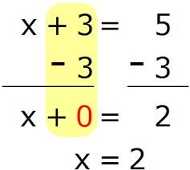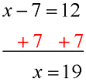
Equation with Multiplication Equation with Division
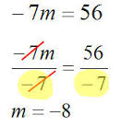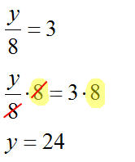
Equation with Fractional Coefficient
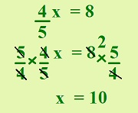
Option #2 – Tape Diagrams/Bar Models
Example: 4x + 32 = 240 → 4x = 208 → x = 52
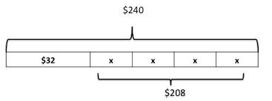
Student Notes:
Example 1:
Meagan spent $56.58 on three pairs of jeans. If each pair of jeans costs the same amount, write an algebraic equation that represents this situation and solve to determine how much one pair of jeans cost.
$56.58
J J J

Solve 2 Ways:

Example 2:
Julie gets paid $20 for babysitting. He spends $1.99 on a package of trading cards and $6.50 on lunch. Write and solve an equation to show how much money Julie has left.
20
1.90 6.50 money left over (m)

Solve 2 Ways:

6.EE.8 Write an inequality of the form x > c or x < c to represent a constraint or condition in a real-world or mathematical problem. Recognize that inequalities of the form x > c or x < c have infinitely many solutions; represent solutions of such inequalities on number line diagrams.

**You will solve inequalities the same way that you solve equations!
Sample Problem:
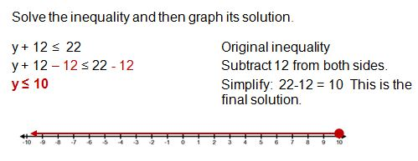
Graphing Inequalities: Observe the solution column and see how it impacts the circle (open or closed) and the directions that the arrow is shaded.
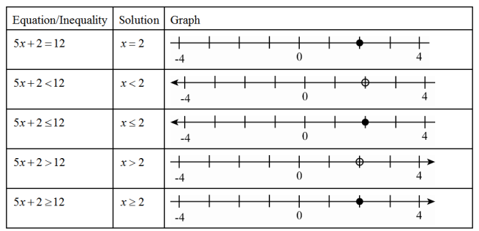
TRAPS!!!
1) Variable on the left → 7≥ h is rewritten as h ≤ 7
2) Any problem where you multiply or divide by a negative number
- -3m ≤ 15 becomes m ≥ -5

- - $\frac{m}{8}$ ≥ 3 becomes m ≤ -24
Student Notes:
Example 1:
The class must raise at least $100 to go on the field trip. They have collected $20. Write an inequality to represent the amount of money, m, the class still needs to raise. Represent this inequality on a number line.

Example 2:
Graph x ≤ 4.

Example 3:
The Flores family spent less than $200.00 last month on groceries. Write an inequality to represent this amount and graph this inequality on a number line.

6.EE.9 Use variables to represent two quantities in a real-world problem that change in relationship to one another; write an equation to express one quantity, thought of as the dependent variable, in terms of the other quantity, thought of as the independent variable. Analyze the relationship between the dependent and independent variables using graphs and tables, and relate these to the equation.

Independent Variable - the variable that can be changed and is graphed on the x-axis
Dependent Variable - the variable that is affected by the change in the independent variable and is graphed on the y-axis 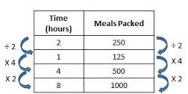
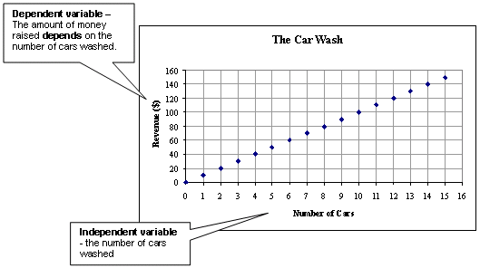
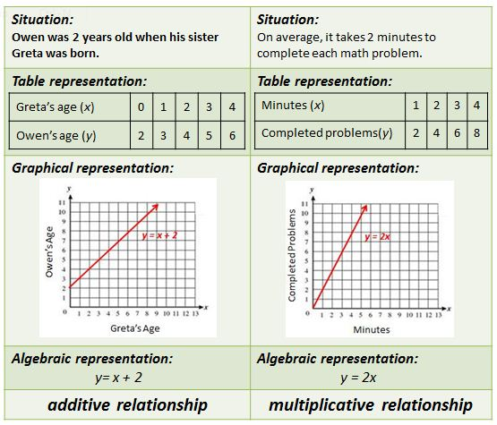
Example 1:
What is the relationship between the two variables? Write an expression that illustrates the relationship.
x | 1 | 2 | 3 | 4
y | 2.5 | 5 | 7.5 | 10

Example 2:
What is the relationship between the two variables? Write an expression that illustrates the relationship.
