Inequalities in the Real World

Artifact #1 – Theme Parks (Simple Inequalities)
You first mission is to create a theme park based on your favorite Disney/Pixar animated movie. The finished product should be high quality, colorful and full of inequalities. This is a great opportunity to add to your digital portfolio. Be sure to include an explanation of the inequalities found throughout your theme park if you decide to do so.
- Visit http://mcdowellequations.weebly.com and find the tab for “PBL”.
- Explore Part 1 and Part 2
- Select a Disney/Pixar movie
- Create your theme park using the directions provided on the learning module

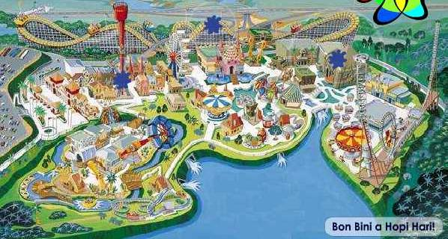

Artifact #2 - ebay Auction (Write and Solve Two Step Inequalities)
Your second assignment is to create a fake ebay auction for a “lot” of items. There are fake ad generators to use, which will allow you to embed code onto your digital portfolio. A good first step would be to check out ebay at home and write down some ideas. A few things to include in your auction are the ebay logo, current bid, end time, shipping cost, history, meet the seller, feedback, payment details, description of the items, and visuals of the items. Remember to make this as authentic as possible! The final step of the process is to solve the two step inequality so we know what each individual item from the lot costs. This is another opportunity to add to your digital portfolio.

